Social Pedagogy Diamond course

‘A child has a hundred possibilities: A child has a hundred languages, a hundred hands,   
a hundred thoughts. S/he has a hundred ways of thinking, a hundred ways of playing,

a hundred ways of talking.’

(Loris Malaguzzi, Italian pedagogue and founder of Reggio Emilia)

# Course Outline

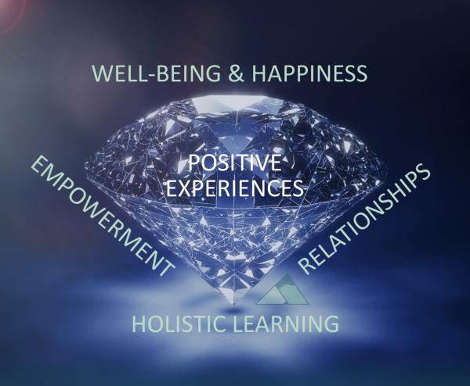The Diamond Model is one of the most powerful concepts in social pedagogy and highlights that each person has a wealth of resources to offer which professionals can draw upon in order to empower people to create meaningful change in their lives. The model is a constant reminder that, as practitioners, we can only facilitate change in another person if we focus on uncovering and nurturing their potential, and support them in bringing out their inner diamonds.

ThemPra’s Social Pedagogy Diamond course outlines the overarching aims and aspirations of social pedagogy and illustrates the role of social pedagogical practitioners to help children, young people or other individuals across the age range to discover their innate potential and resources. As an introductory 3-day course aiming to raise awareness and create further interest in social pedagogy, the course will enable you to experientially engage with core social pedagogical concepts and to explore the relevance of social pedagogy for your practice. Following the Diamond Model, we will explore how you can enhance children’s/adults’ well-being and happiness, create holistic learning opportunities and further strengthen their relationships in ways that empower the people you support in your practice.

The Diamond course is facilitated over 3 consecutive days using a variety of learning methods to make social pedagogy become real – through experiential learning activities, group discussions, theoretical inputs, reflection and action planning on how you can help other people shine.

Each day starts at 9.30am and finishes at 4.30pm, and we ask that participants commit to attending all days (to be able to take the most coherence and understanding from the course), to come with comfortable shoes and cold weather clothing (to enable easy participation in activities, some of which may take place outside), lots of curiosity and questions.

# Learning Aims

By connecting social pedagogical concepts and principles to practice, we aim to:

1. provide you with an **enduring understanding** of:

* Social pedagogy as an ethical orientation based on recognition that human beings are intrinsically rich, have unique value and potential
* How to convey this belief in everyday interactions and relationships through *Haltung* (congruence between values and actions) and critical reflection
* The Diamond Model as a guiding tool to developing practice in accordance with the core aims of social pedagogy

1. ensure you **know and are able to apply** a positive, resource-based concept of human beings in your everyday practice
2. make you further **familiar with** nonviolent communication as a way of developing supportive and empowering relationships

# Themes

* Social pedagogy and its ethical commitment to respecting human dignity – *Haltung,* the Diamond Model and the ‘rich child’
* The subjective and holistic nature of well-being and happiness
* The importance of joy, empathy and compassion
* Learning as a holistic, immersive, voluntary, active and meaningful process – the learning zone, multiple intelligences
* Everyday situations’ learning potential – when do we learn best
* The importance of connecting the professional and the personal in developing authentic and meaningful relationships – the 3 Ps
* How to develop strong and trusting relationships by engaging with an individual in an activity – the Common Third and the significance of ‘being with’ rather than ‘doing for’
* How to use formal professional power as a means to support rather than control – enabling empowerment
* Why and how to involve individuals meaningfully in decisions
* The power of positive experiences in creating change
* How experiences can be positively reframed

# Course Details

**Date:** 21st – 23rd March, 2017 | 9.30am – 4.30pm

**Venue:** Townhead Village Hall, 60 St Mungo Avenue, Glasgow, G4 0PL

**Costs (incl. finger food lunch):** 1 person (self-funded): £340 (+ VAT)

1 person (employer-funded): £360 (+ VAT)

*Employers booking 3 or more places will receive a 5% discount*

# Course Facilitators

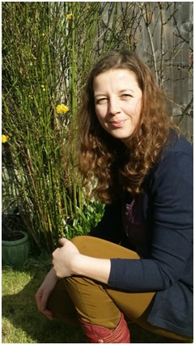  
Alexandra Priver (left) and Charlotte Firing (right) are both internationally experienced practitioners in social pedagogical settings and longstanding facilitation expertise. They have led on a number of ThemPra’s pioneering projects in Scotland, including *Head, Heart, Hands*, Camphill Scotland, Kibble, Dundee Early Intervention Team, East Ayrshire, West Lothian, Orkney Islands, and our EU Leonardo Mobility funded projects exploring social pedagogy in Danish care settings. Please feel free to contact them at [alex@thempra.org.uk](mailto:alex@thempra.org.uk) and [charlotte@thempra.org.uk](mailto:charlotte@thempra.org.uk) or check out their [3P profiles](http://www.thempra.org.uk/thempra/who-we-are/) to find out more.

# Booking Form

To book a place on this course, please complete the below form and return this to [sylvie@thempra.org.uk](mailto:sylvie@thempra.org.uk) at your earliest convenience.

*Title Click or tap here to enter text.*

*First name Click or tap here to enter text.*

*Surname Click or tap here to enter text.*

*Organisation Click or tap here to enter text.*

*Email address Click or tap here to enter text.*

*Phone no Click or tap here to enter text.*

*Special requirements[1] Click or tap here to enter text.*

*Invoice to Click or tap here to enter text.*

We’ll send you a booking confirmation email, together with an invoice. If you have any further questions or would like to discuss the course with us, please feel free to get in touch with [Sylvia](mailto:sylvie@thempra.org.uk) at any time.

# Terms and Conditions

The below terms and conditions apply to any bookings for courses offered by ThemPra Social Pedagogy CIC, and any booking will be considered as an acceptance of these terms and conditions.

1. Bookings:

Please direct bookings and any enquiries to Sylvia Holthoff at [sylvie@thempra.org.uk](mailto:sylvie@thempra.org.uk). Bookings will be confirmed upon receiving the above booking form.

1. Participant Minimum Numbers:

The number of participants for courses is 10 to 18. We reserve the right to cancel courses up to 7 days in advance if the minimum number of 10 participants isn’t reached.

1. Cancellations and Refunds:

If you have to cancel your booking, we will refund you in accordance with the below timetable:  
  
 More than 28 days to the course start date = 100% refund

28 days or less to the course start date = 70% refund

14 days or less to the course start date = 30% refund

7 days or less to the course start date = non-refundable

ThemPra reserves the right to cancel courses up to 7 days in advance – or less for circumstances beyond our control (force majeure). In these cases your course fee will be fully refunded, and we will provide you with further details about alternative dates for the course.

1. Confidentiality:

ThemPra aims to create a learning environment where our participants feel trusted. As such we take confidentiality very seriously and will not disclose details about individual participants’ performance or statements unless we have reason to believe that the welfare of children or vulnerable adults supported by a participant is at risk. As a course participant you agree to keep secure and not disclose any information of a confidential nature obtained by reason of the course received except information which is already in the public domain.

1. Data Protection:

ThemPra will not share your personal data with any third parties for any reasons without your prior consent. Such data will only be collected, processed and held in accordance with ThemPra’s rights and obligations arising under the provisions and principles of the Data Protection Act 1998.

1. Copyright:

ThemPra retains its intellectual property rights in all of its materials, including any that have been or will be developed or adapted by ThemPra for the purposes of this project. We grant you permission to use ThemPra’s materials internally for educational purposes. Materials published on our website [www.thempra.org.uk](http://www.thempra.org.uk) are subject to a creative commons license and may be used for non-commercial purposes if they are attributed to us as original authors. If ThemPra becomes aware of any unauthorised use, then legal action may be taken to stop such activity and to seek compensation.

1. Right to Dismiss:

ThemPra reserves the right, at its sole discretion, to dismiss any participant from the course or seminar on the grounds of misconduct, non-payment of the course fee or non-attendance of substantial parts of the course.

1. Please include any dietary requirements, accessibility needs or other ways in which we can support you in fully participating in this course.