Social Pedagogical Leadership
  - ‘Great leaders find ways to connect with their people and help them fulfil their potential.’ Steven J. Stowell

Course Outline
Leadership is seen as vital to realising aspirations, achieving high-performing teams and creating positive cultures of care. The challenge, however, lies in how we can practice leadership in ways that are authentic and draw out our own and others’ potential. Just as with geese flying in V formation, leadership isn’t just about the people in the top positions – it’s essential to develop each person’s leadership potential.
With its strong emphasis on more equal relationships, learning processes, a shared life-space and ethics as first practice, social pedagogy has important implications for leadership at every level of an organisation. For the development of a social pedagogical culture within your service, it is vital that you and other leaders (such as senior managers, team leaders and other key people) know how to encourage teams to navigate complexity and are able to make situated judgments.
This three-day course provides an excellent opportunity for you as a leader to explore how key principles in social pedagogy translate into leadership, what this means for you, your team, the wider organisation and, most importantly, how social pedagogical leadership can benefit the individuals, families or groups supported by your organisation. To ensure that all course participants have a basic understanding of social pedagogy prior to this course, we will provide you in advance with reading materials and encourage you to register for our Massive Open Online Course in Social Pedagogy across Europe (available on Coursera).
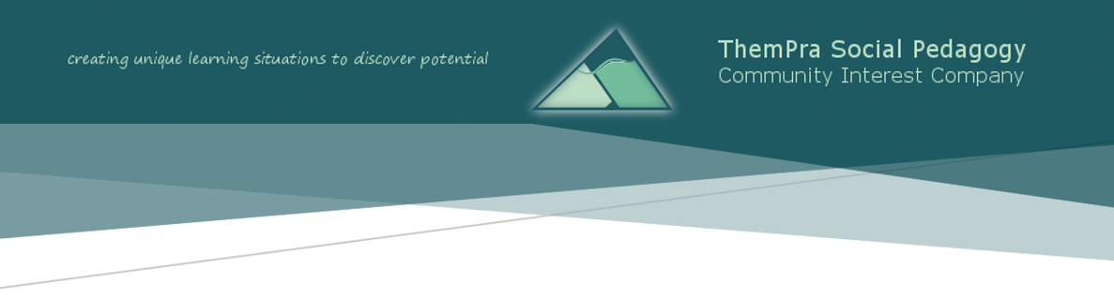
In facilitating the course we will draw on a variety of learning methods that make social pedagogical leadership come to life – through experiential learning activities, group discussions, theoretical inputs, reflection and action planning on how you can develop your own leadership.
This course is endorsed by the Social Pedagogy Professional Association and forms the introductory module of the MA in Social Pedagogy Leadership at the University of Central Lancashire. Participants therefore have the option to gain accreditation and join the MA programme.

Learning Aims
By connecting social pedagogical concepts and principles to practice, we aim to:
- provide you with an enduring understanding of:
- Social pedagogy as an ethical orientation based on recognition that human beings are intrinsically rich, have unique value and potential
- How to convey this belief in everyday interactions and relationships through your social pedagogical leadership
- How you can create and develop social pedagogical teams and organisations within a positive culture of care
- ensure you know and are able to apply:
- Relevant social pedagogical theories and principles for everyday leadership practice
- How you can initiate and sustain change within a complex practice environment
- make you further familiar with:
- The role of communication and empathic listening in social pedagogical leadership
- Ideas and activities for future team development, supervision and your personal leadership style development

Themes
- Core concepts in social pedagogy and their implications for leadership
- Introduction to and perspectives on social pedagogical leadership
- Leadership as pedagogy
- The notion of Haltung and ethics as foundational for social pedagogical practice
- The pedagogy of listening and recognition for leaders
- Nurturing motivation
- Creating, developing and sustaining a social pedagogical culture of care
- Myths and mechanisms of scaling and diffusion

Course Details
Date: 8th – 10th July, 2020 | 9.30am – 4.30pm
Venue: Quaker Meeting House Chelmsford, Rainsford Road
Chelmsford CM1 2QL

Costs (incl. finger food lunch): 1 person (self-funded): £300
(max. 3 places available at this rate)
1 person (employer-funded): £360
(employers booking 3 or more places will receive a 5% discount)

Our Course Facilitators
We’re Alexandra Priver (left) and Charlotte Firing (right) from ThemPra. We’re both internationally experienced practitioners in social pedagogical settings and have longstanding facilitation and leadership expertise. We’ve led on a number of ThemPra’s pioneering projects in England and Scotland, including Head, Heart, Hands, Dundee Early Intervention Team, St Christopher’s Fellowship, and our EU Leonardo Mobility funded projects exploring social pedagogy in Danish care settings. We’re also co-delivering the MA in Social Pedagogy Leadership in partnership with the University of Central Lancashire.
Please feel free to contact us at alex@thempra.org.uk and charlotte@thempra.org.uk or check out our
3P profiles to find out more.

Booking Form
To book a place on this course, please complete the below form and return this to sylvie@thempra.org.uk at your earliest convenience.
Title | Click or tap here to enter text.
First name | Click or tap here to enter text. | Surname | Click or tap here to enter text.
Organisation | Click or tap here to enter text. | Job title | Click or tap here to enter text.
Email address | Click or tap here to enter text. | Phone no | Click or tap here to enter text.
Special requirements | Click or tap here to enter text. | Invoice to | Click or tap here to enter text.

We’ll send you a booking confirmation email, together with an invoice and payment details. If you have any further questions or would like to discuss the course with us, please feel free to get in touch with Sylvia at any time.

Terms and Conditions
The below terms and conditions apply to any bookings for courses offered by ThemPra Social Pedagogy CIC, and any booking will be considered as an acceptance of these terms and conditions.
- Bookings:
Please direct bookings and any enquiries to Sylvia Holthoff at sylvie@thempra.org.uk. Bookings will be confirmed upon receiving the above booking form.

- Participant Minimum Numbers:
The number of participants for courses is 10 to 18. We reserve the right to cancel courses up to 7 days in advance if the minimum number of 10 participants has not been reached.

- Cancellations and Refunds:
If you have to cancel your booking, we will refund you in accordance with the below timetable:
More than 28 days to the course start date = 100% refund
28 days or less to the course start date = 70% refund
14 days or less to the course start date = 30% refund
7 days or less to the course start date = non-refundable
ThemPra reserves the right to cancel courses up to 7 days in advance – or less for circumstances beyond our control (force majeure). In these cases your course fee will be fully refunded, and we will provide you with further details about alternative dates for the course.

- Confidentiality:
ThemPra aims to create a learning environment where our participants feel trusted. As such we take confidentiality very seriously and will not disclose details about individual participants’ performance or statements unless we have reason to believe that the welfare of children or vulnerable adults supported by a participant is at risk. As a course participant you agree to keep secure and not disclose any information of a confidential nature obtained by reason of the course received except information which is already in the public domain.

- Data Protection:
ThemPra will not share your personal data with any third parties for any reasons without your prior consent. Such data will only be collected, processed and held in accordance with ThemPra’s rights and obligations arising under the provisions and principles of the General Data Protection Regulation 2018 and the Data Protection Act 1998.

- Copyright:
ThemPra retains its intellectual property rights in all of its materials, including any that have been or will be developed or adapted by ThemPra for the purposes of this project. We grant you permission to use ThemPra’s materials internally for educational purposes. Materials published on our website www.thempra.org.uk are subject to a creative commons license and may be used for non-commercial purposes if they are attributed to us as original authors. If ThemPra becomes aware of any unauthorised use, then legal action may be taken to stop such activity and to seek compensation.

- Right to Dismiss:
ThemPra reserves the right, at its sole discretion, to dismiss any participant from the course or seminar on the grounds of misconduct, non-payment of the course fee or non-attendance of substantial parts of the course.

Please include any dietary requirements, accessibility needs or other ways in which we can support you in fully participating in this course.

